Day2 :

Getting Started with AAzure.

We studied about how to create an azure account for 1 month free and just explored some services which are availiable.

Day3

Resource groups :

i)A resource group is a container that holds related resources for an Azure solution.

ii) It is  is a logical container into which Azure resources like web apps, databases and storage accounts are deployed and managed.

The resource group stores metadata about the resources. When you specify a location for the resource group, you're specifying where that metadata is stored. For compliance reasons, you may need to ensure that your data is stored in a particular region.

Azure resource manager

**Azure Resource Manager (ARM)** is the deployment and management service for Azure. It provides a consistent management layer that enables you to deploy resources with declarative templates. ARM templates describe the resources you need and their configurations, allowing you to deploy and update resources in a predictable manner.

Usecases:

* Manage your infrastructure through declarative templates rather than scripts.

For more visit:

<https://learn.microsoft.com/en-us/azure/azure-resource-manager/management/overview>

We studied about:

What is resource group?

What is ARM?

We also did a practical demo of creating a resource group.

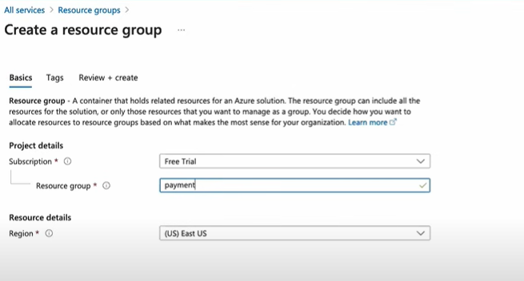

Day4:

**Deploy Jenkins on Azure VM | Azure VM Types explained**

What are the azure vm comute types:

i) general purpose

ii) compute optimized: high cpu to memory ratio.

iii) memory optimized: high memory to cpu ratio

iv) storage optimized: high disk throughput

v) GPU: Specially targeted for high graphics and video editng as well as model traning.

There are different series for the VM size and usually a devops engineer gets a request of how much size they want accordingly we built a Vm.

For more visit: <https://learn.microsoft.com/en-us/azure/virtual-machines/sizes>

<https://azure.microsoft.com/en-in/pricing/details/virtual-machines/series/>

# Virtualization: An In-Depth Explanation

## Background

In traditional computing, a single physical server runs a single operating system, and applications are installed directly on that OS. This approach has limitations, such as underutilization of hardware resources, difficulty in managing multiple servers, and lack of flexibility in scaling.

**Virtualization** addresses these challenges by introducing a layer of abstraction between the hardware and the operating system. It enables the creation of multiple virtual instances, each running its own operating system and applications, on a single physical server. This technology has become fundamental in modern data centers and cloud computing environments.

## Components of Virtualization

1. **Hypervisor (Virtual Machine Monitor):**
   * The hypervisor is a crucial component of virtualization. It sits between the hardware and the operating systems, managing and allocating resources to virtual machines (VMs).
   * There are two types of hypervisors: Type 1 (bare-metal) runs directly on the hardware, while Type 2 (hosted) runs on top of an existing operating system.
2. **Virtual Machines (VMs):**
   * VMs are the instances created by the hypervisor. Each VM operates as an independent computer with its own virtualized hardware, including CPU, memory, storage, and network interfaces.
   * Multiple VMs can run on a single physical server, allowing for efficient resource utilization.

Creating a Azure Virtual Machine.

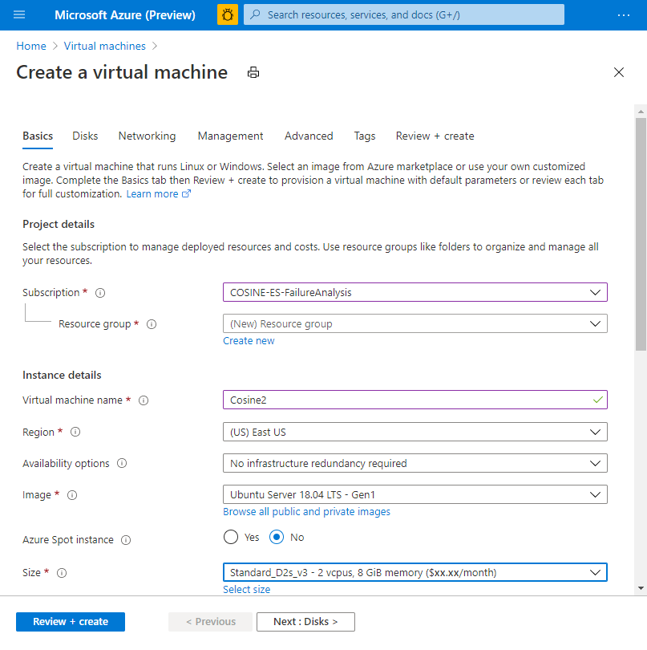

Just install a basic Vm and review+ create it it will ask for generation of a private key so click on it.

Once it is install, make an ideal practice of connecting a linux box by gitbash tool .

<https://git-scm.com/downloads>

Once the gitbash is downloaded follow the below steps:

1)ssh -i (path of .pem file) azureuser@ip address of that VM

2)chmod 600 (local path of .pem file)to remove the warning which comes.

3)Server will be accessible

To deploy a basic jenkins application on the server follow the below steps:

i)sudo apt update

ii)sudo apt install openjdk-11-jre

iii)curl -fsSL https://pkg.jenkins.io/debian/jenkins.io-2023.key | sudo tee \

/usr/share/keyrings/jenkins-keyring.asc > /dev/null

echo deb [signed-by=/usr/share/keyrings/jenkins-keyring.asc] \

https://pkg.jenkins.io/debian binary/ | sudo tee \

/etc/apt/sources.list.d/jenkins.list > /dev/null

sudo apt-get update

sudo apt-get install Jenkins

### Jenkins Installation Steps

<https://github.com/iam-veeramalla/Jenkins-Zero-To-Hero>

**Note: ** By default, Jenkins will not be accessible to the external world due to the inbound traffic restriction by Azure. Open port 8080 in the inbound traffic rules. two types of ports inbound port and outbound port

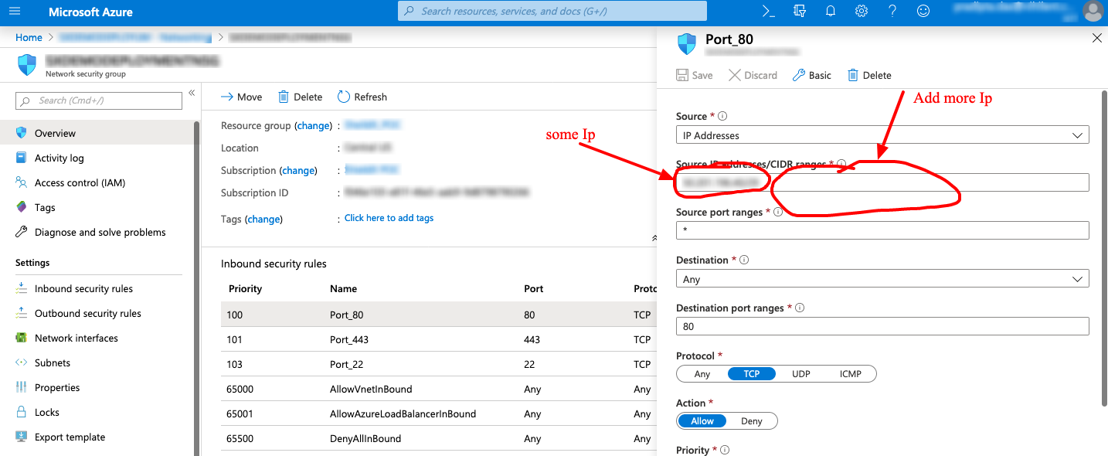

In our case the destination port range will be port 8080.

### Login to Jenkins using the below URL:

<http://Ipaddressofmachine:8080>

you will get the below interface on browser.

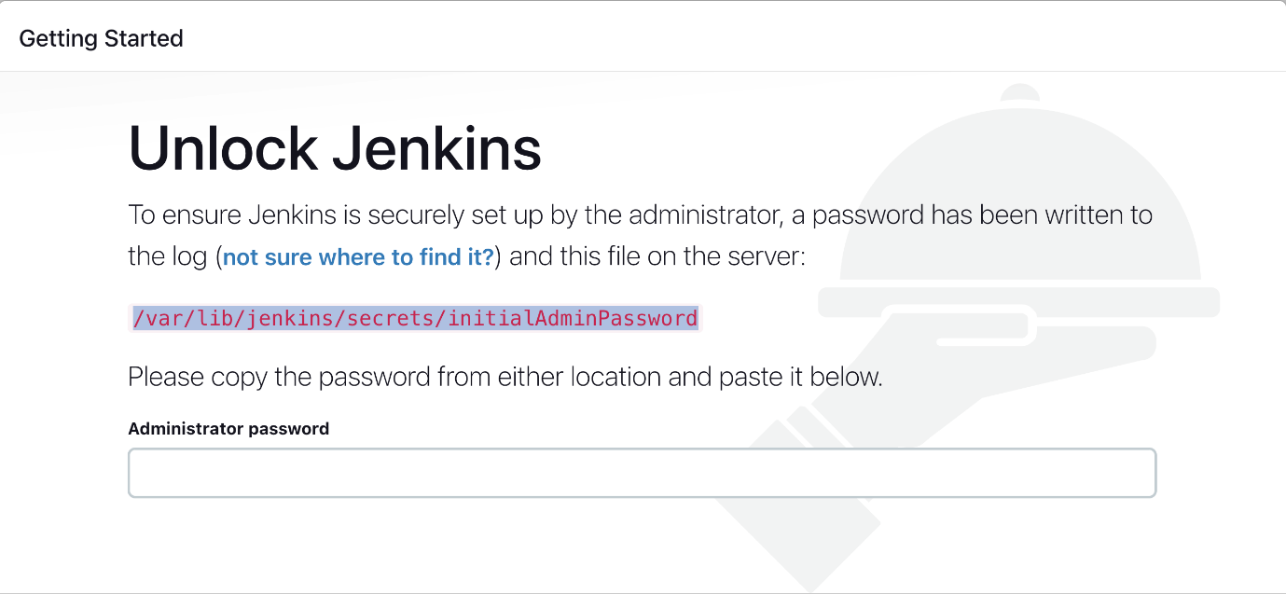

Every aplication deployed on your virtual machine will have a dedicated port assigned.